|  |  |  |  |  |  |
| --- | --- | --- | --- | --- | --- |
|  |  |  |  |  | logo1.png |

|  |  |  |  |
| --- | --- | --- | --- |
| Course Name | | Zoho Books | |
| College Name | | Mangayarkarasi College of Arts and Science for Women Paravai, Madurai - 625002 | |
| College Code | | MKU251 | |
| Skill Offering Id | |  | |
| Project Title | | Preparation and Maintenance of Zoho books for Keerthi Sweets | |
| Project Submitted To | | Madurai Kamaraj University ( Naan Mudhalvan Scheme(TNSDC)) | |
| Year | | 2023 | |
| Department | | B.com | |
| Semester | | 5 | |
| Group Number | | 1 | |
| Total Members of the Group | | 4 | |
| Group Members Details | | | |
| Name of the Member | University Register. No | | Student NM ID |
| N.varsha | C1C15910 | | 689F6B9FA32C884B9374C25746CC9A4A NM2023TMID36931 |
| T.shanmuga valli | C1C15900 | | 830FB696096E065A30A40D049B7A066D |
| V.meenakshi | C1C15880 | | D708B6FD1C61D31A0DC46EDEA820805D |
| T.bhavani | C1C15859 | | DEA30E3C5B638A8A81D43E295BD4CE91 |
|  |  | |  |
| Under the Guidance | | MS.C.M.Priyanka | |
| SPOC | | Ms.P.UMADEVI | |

**Analysing Housing Prices in Metropolitan areas in India**

1. **Introduction.**

***1.1 Overview***

**Keerthi Sweets a Manufacturer and Trader of Sweets, relies on Zoho Books to manage their inventory,**

**handle purchase orders, and generate invoices for their customers. They can track stock levels,**

**manage supplier payments, and generate financial reports. Zoho Books helps them streamline their**

**wholesale operations and optimize inventory management.**

***1.2 Purpose***

**Keerthi Sweets is a renowned manufacturer and trader of delectable sweets, catering to both wholesale**

**And retail customers. With a rich heritage spanning several decades, Keerthi Sweets has earned a**

**Reputation for its commitment to quality, authenticity, and customer satisfaction. Specializing in a wide**

**Variety of traditional and innovative sweets, they combine traditional recipes with modern techniques**

**To create flavors that tantalize taste buds**

1. **Problem Definition and Design Thinking**
   1. 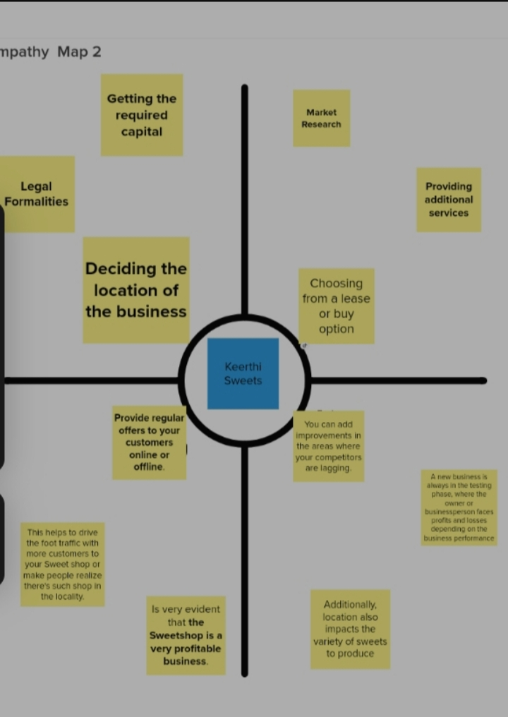Empathy Map

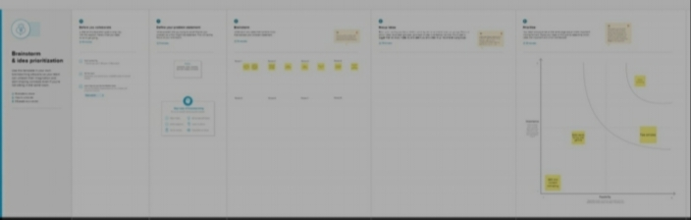 **2.2 Ideation and Brainstroming Map**

1. **Result:**

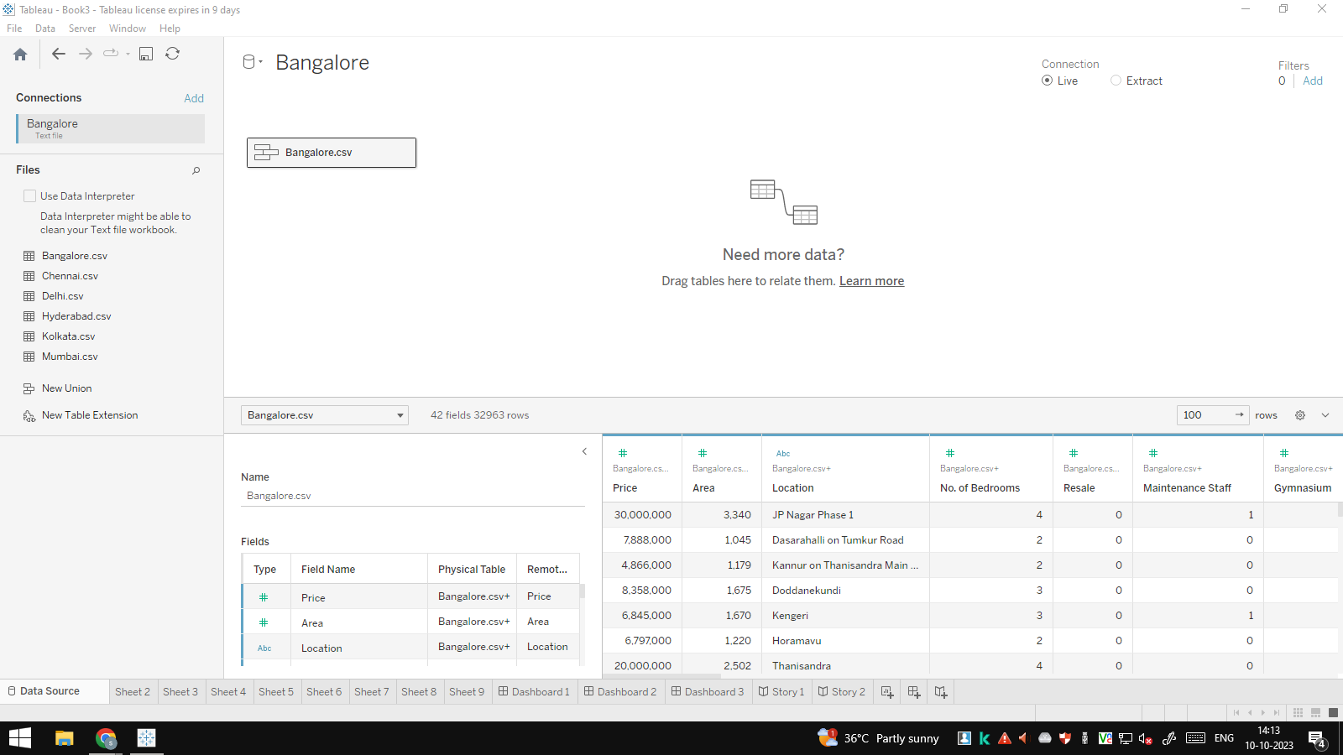

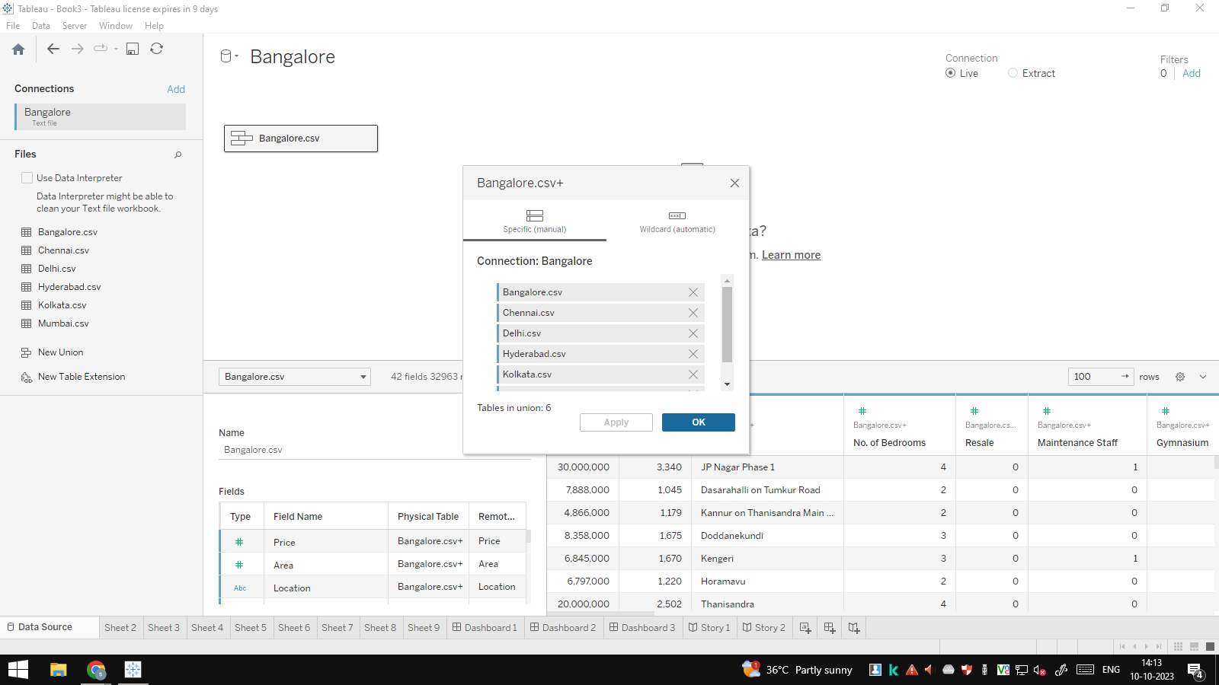

**To sign up for Zoho Books:**

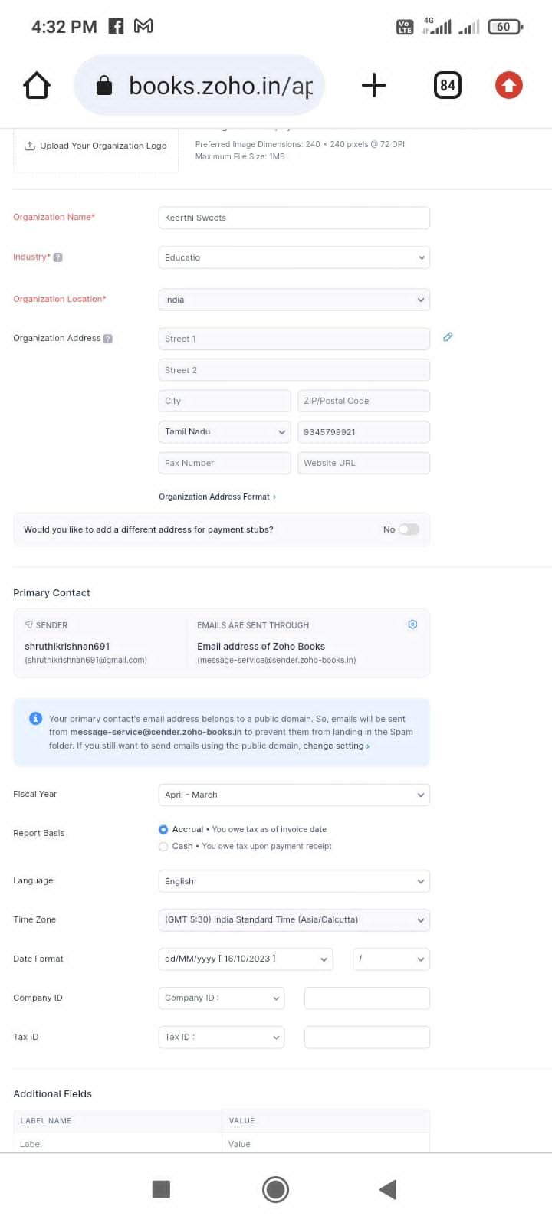

**Activity 2: Introduction**

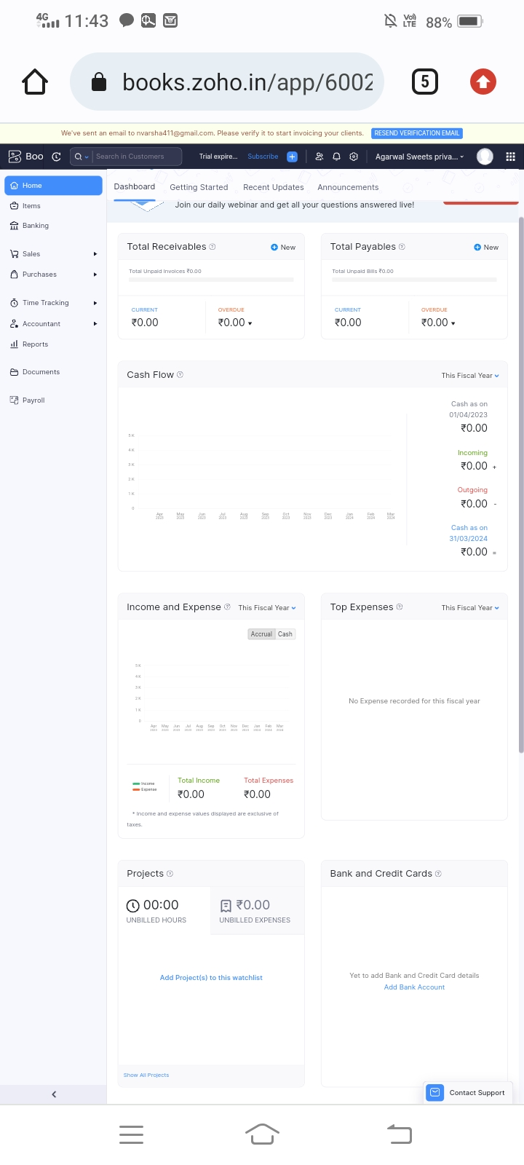

**Milestone 2: Products/Items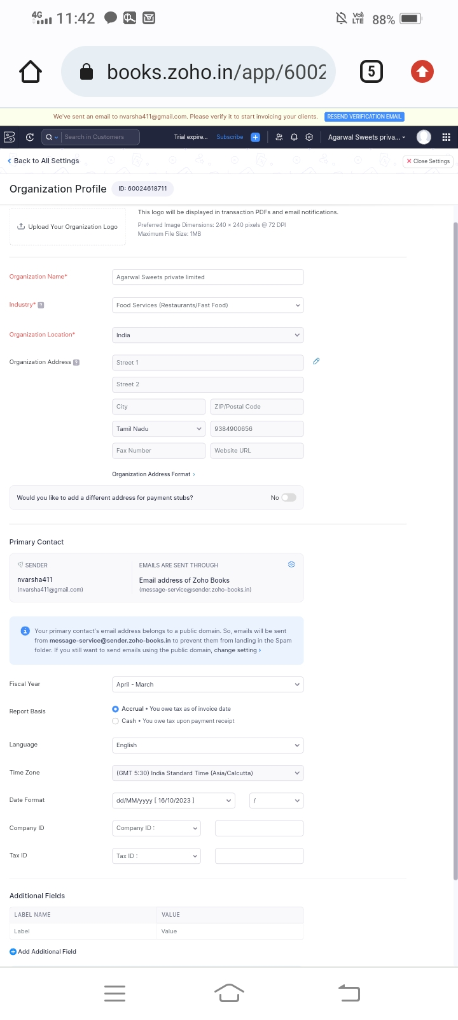Activity 1: Creation**

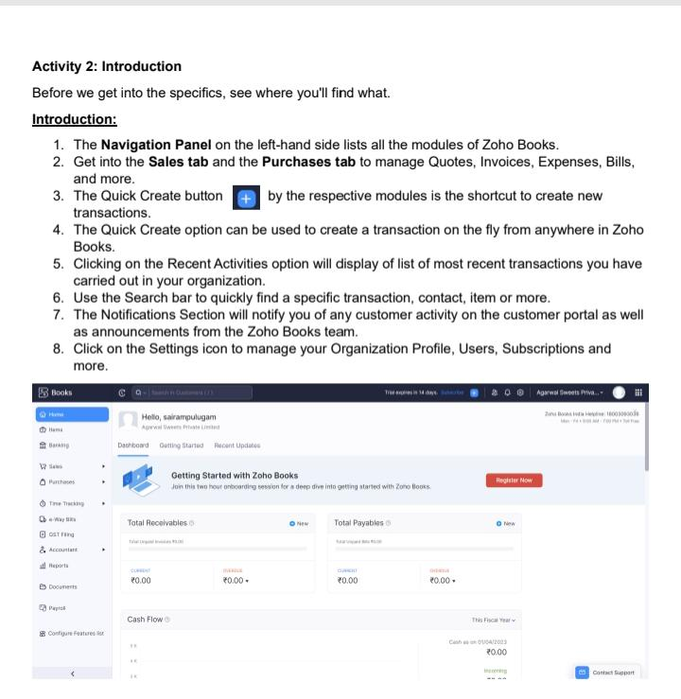

**Activity 2: Rewiew of Items after Addition**

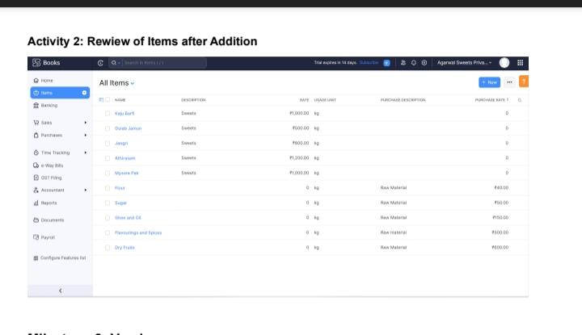

**Milestone 3: Vendors**

**Activity 1: Vendors Creation**

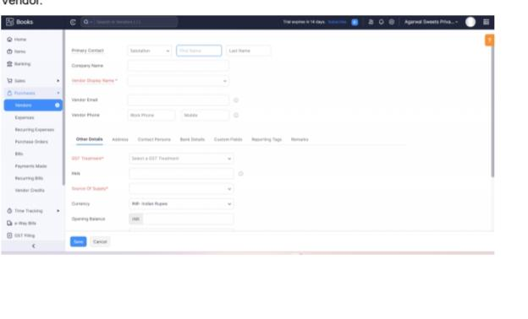

**Activity 2: Review of Vendors List**

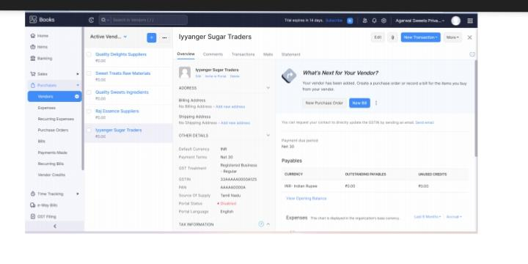

**Milestone 4: Purchases**

**Activity 1: Purchase Order Creation**

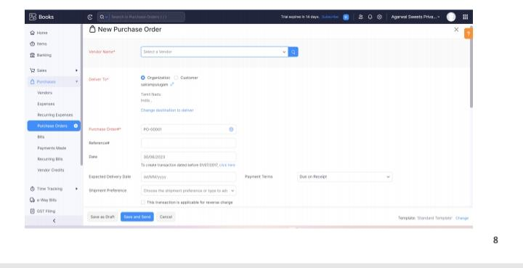

**Activity 2: Purchase Order to Purchase Bills Convertion**

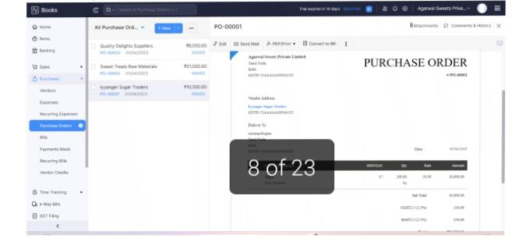

**Activity 3: Direct Vendor Purchases Bills Creation:**

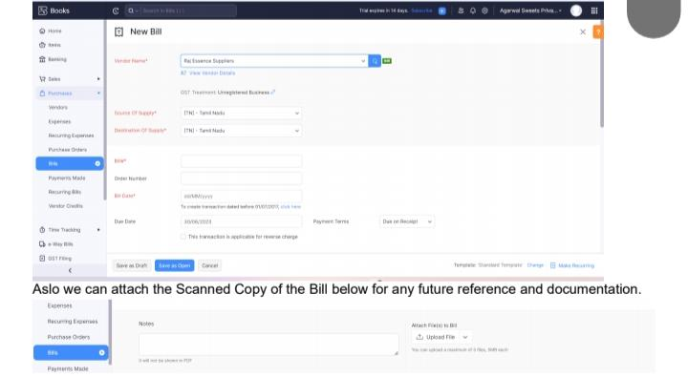

**Activity 4: Payment Marking to Purchase Bill**

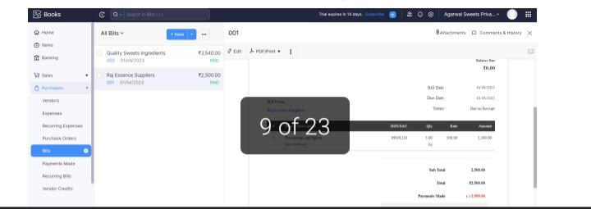**Activity 5: Reconciliation of Open Bills**

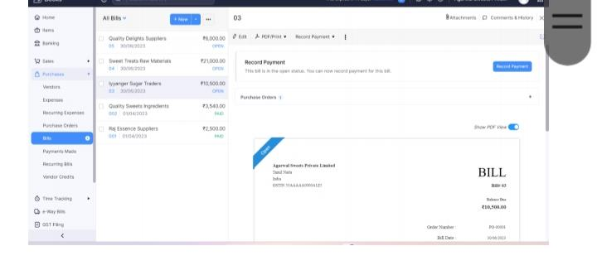

**Milestone 5: Customers**

**Activity 1: Customers Creatio**

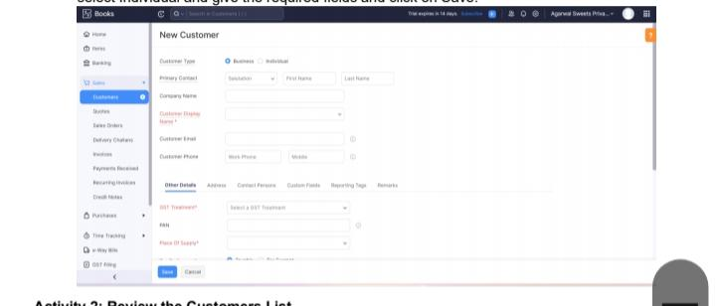

**Activity 2: Review the Customers List**

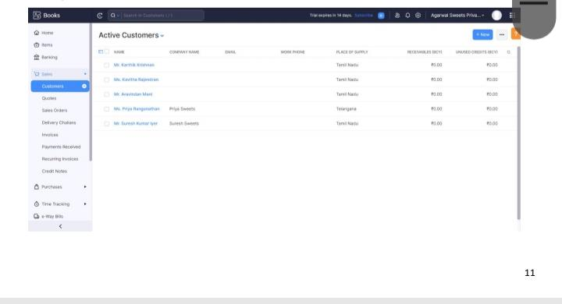

**Milestone 5: Customers**

**Activity 1: Customers Creation:**

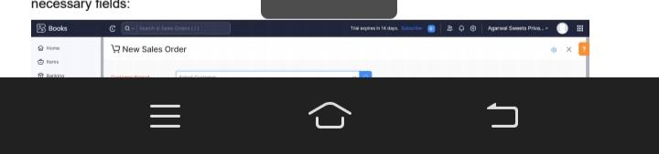

**Activity 2: Review the Customers List**

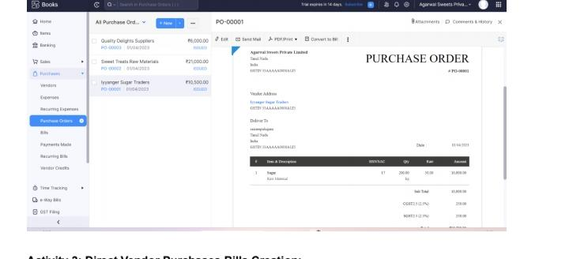

**Milestone 6: Sales**

**Activity 1: Sales Order Creation**

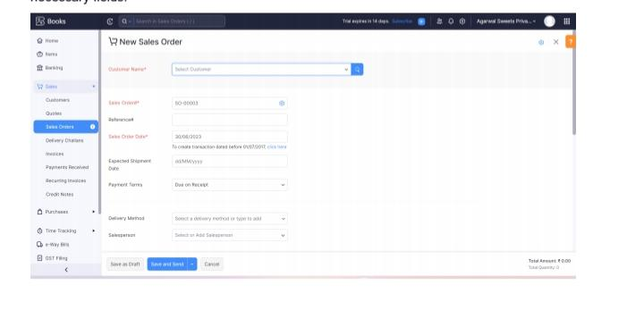

**Activity 2: Sales Order to Sale Invoice Convertion**

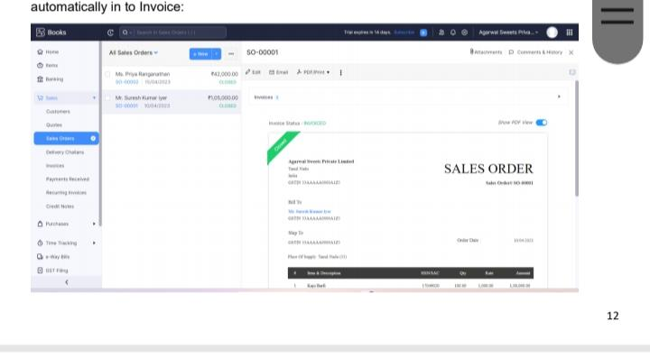

**Activity 3: Direct Sale Invoices**

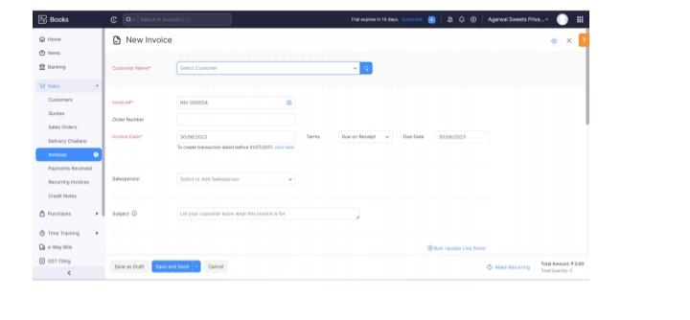

**Milestone 11: Bank Entries**

**.Date Paritculars Debit Credit Balance**

**01-04-2023 Capital Deposit 100000 100000**

**01-04-2023 Cash Withdrawl for petty cash 10000 90000**

**10-04-2023 Paid to Iyyanger Sugar Traders 10500 79500**

**10-04-2023 Paid to Sweet Treats Raw Materials 21000 58500**

**10-04-2023 Paid to Quality Delights Suppliers 6000 52500**

**25-04-2023 Amount received from customer Mr. Suresh Kumar 105000 157500**

**30-04-2023 Rent Payment 23600 133900**

**30-04-2023 Petty Cash Deposit 50000 183900**

1. **Conclusion:**

Keerthi Sweets is a Private Limited company also registered under GST in Tamil Nadu. Keerthi Sweets is a Manufacturer and trader of various sweets in wholesale and retail, it has a wide range of customers (B2B & B2C) all over the state and it procures raw material from various suppliers in the state. It operates at a Gross Profit margin of 50%.

1. **Future scope:**

Sweet business is very profitable and financial rewarding, mostly yield a good profits in Business you can make private label any of your products , this gives you an advantage by Presenting exclusive products to your customers .